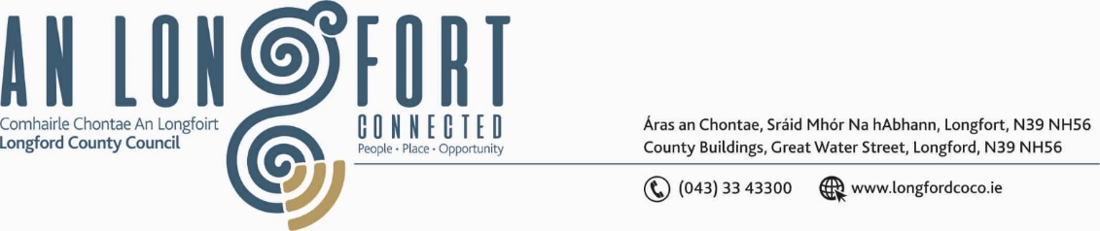

**GRANARD MUNICIPAL DISTRICT**

***Please note meeting will be held in Granard Library and via Microsoft Teams.***

**19 July 2022.**

**To: Each Member of Granard Municipal District.**

**Dear Member,**

You are requested to attend a Meeting of Granard Municipal District to be held in Granard Library and **via Microsoft Teams** on **Monday** **25 July 2022 at 3.30pm** to transact business, as set out on the Agenda hereunder.

**Yours sincerely**,

Ann Marie Mc Keon

______________________

**Ann Marie Mc Keon,**

**Meetings Administrator.**

**AGENDA**

Prayer before meeting.

**1.** Confirmation of Minutes as follows: -

* Granard Municipal District Meeting held on 24 May 2022 – copy enclosed.
* Granard Municipal District Committee Meeting held on 24 May 2022 – copy enclosed.
* Granard Municipal District Annual General Meeting on 28 June 2022 – copy enclosed.

**2.** Matters arising from Minutes.

**3.** Declaration of Interest by Members.

**4.** Management Report incorporating Area Engineer’s Progress Report – to follow.

**5.** Community Grant Support Scheme 2022 – enclosed.

**6.** Special Projects/Discretionary Funds 2022 – enclosed.

**7.** Consideration of Part VIII No 92 report - Proposed construction of a single storey dwelling, new entrance, gates and piers, new mains water connection, installation of wastewater treatment system and percolation area together with an ancillary and associated site works at Lettergeeragh, Drumlish, County Longford in Accordance with Section 179 of the Planning and Development Act 2000 (as amended) and Part 8 of the Planning & Development Regulations 2001 (As Amended) - enclosed

**8.** Consideration of Part VIII Number 93 - Aughnacliffe amenity heritage trail, report in Accordance with Section 179 of the Planning and Development Act 2000 (as amended) and Part 8 of the Planning & Development Regulations 2001 (As Amended) – enclosed.

**9.** Consideration of Part VIII Number No 94 Construction of Granard Urban Greenway at Granard, Co. Longford. report in Accordance with Section 179 of the Planning and Development Act 2000 (as amended) and Part 8 of the Planning & Development Regulations 2001 (As Amended) – enclosed.

**10. Notices of Motions, submitted by Councillors, as listed hereunder –**

**Councillor PJ Reilly**

I wish to put a motion forward to the meeting for an update when works are going to start on the public car park at the rear of Granard Garda Station as we were promised last year that this work would commence in early 2022.

**Councillor Colin Dalton**

(i) I call on Longford County Council to consider putting a new bench in the playground in Ballinalee village.

(ii) I call on Longford County Council to consider putting in a road crossing on the Ballinalee Granard Road to accommodate children from Ballinalee School to link up with new walkway and football pitch.

**Councillor Turlough Mc Govern**

I call on Longford County Council to extend the footpath on the main Abbeylara to Coole road to provide access for pedestrian's safe passage to the new Sensory Garden.

**Councillor Garry Murtagh**

I call on Longford County Council to upgrade facilities at Dring car park, bins and signage. Serious consideration regarding the toilet facilities and camping at the car park and ongoing anti-social behaviour.

**Councillor Colin Dalton and Councillor Paraic Brady**

I call on Longford County Council to carry out a low-cost safety scheme at Doherty’s cross Esker Ballinalee. There have been numerous accidents, at this cross, over the last few years and it’s a safety issue.